**Experiment -5**

Creating a docker-compose file

1. Create a docker-compose.yml file

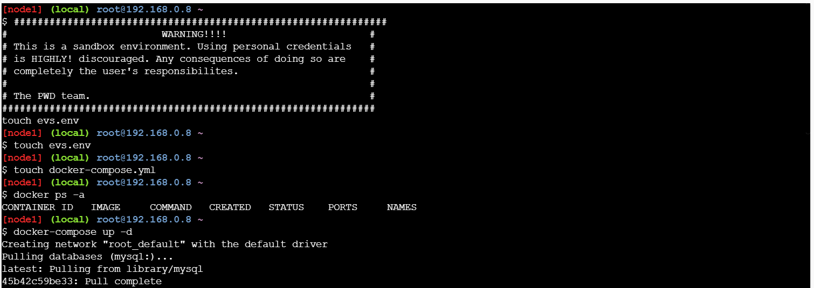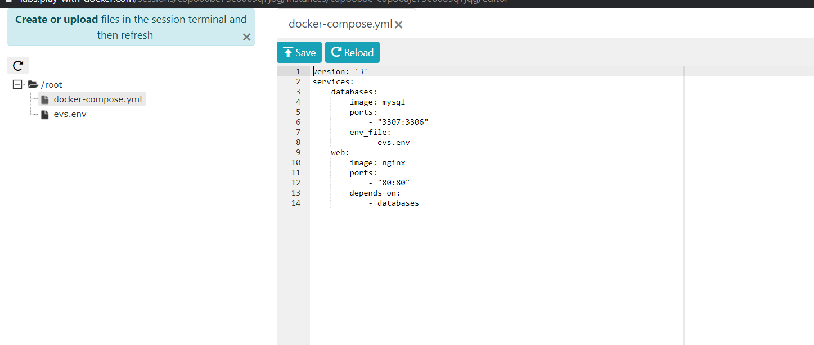

1. Create a environment file to set up web hosting server and database

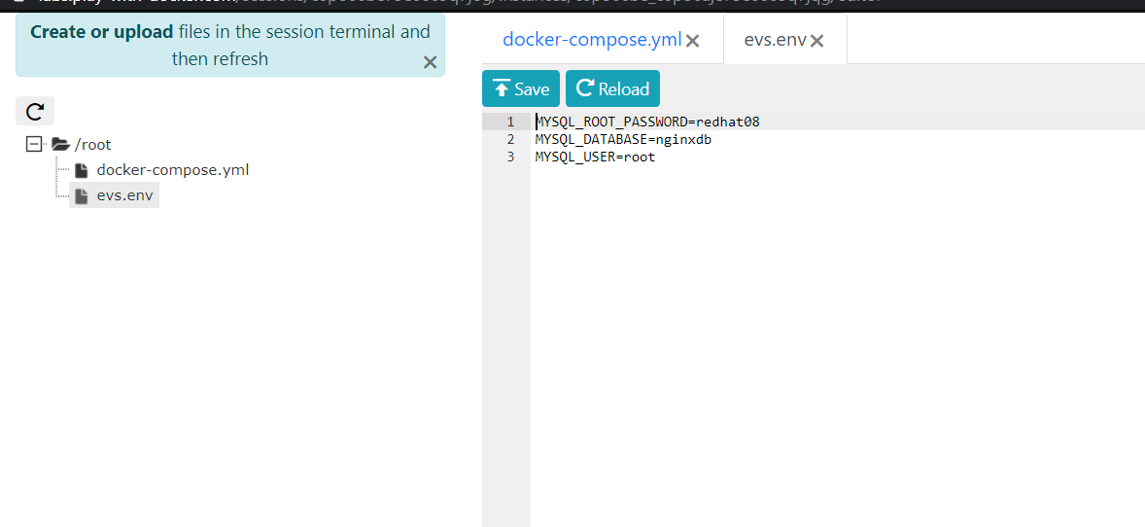

1. Run the file to see docker-compose file up and running

